**Website Traffic Analysis**

**Definition:**

website traffic analysis involves collecting and analyzing data about your website visitors so you can optimize the growth and conversations on your website.

Web traffic is the amount of data sent and receive by the visitors to a website. It is large portion of internet traffic.

This is determined by the number of visitors and the number of pages they visit. Sites monitor the incoming and outgoing to see which parts of pages of their site are popular and if there are any apparent trends, such as one specific page being viewed mostly by people in a particular country.

**Design**:

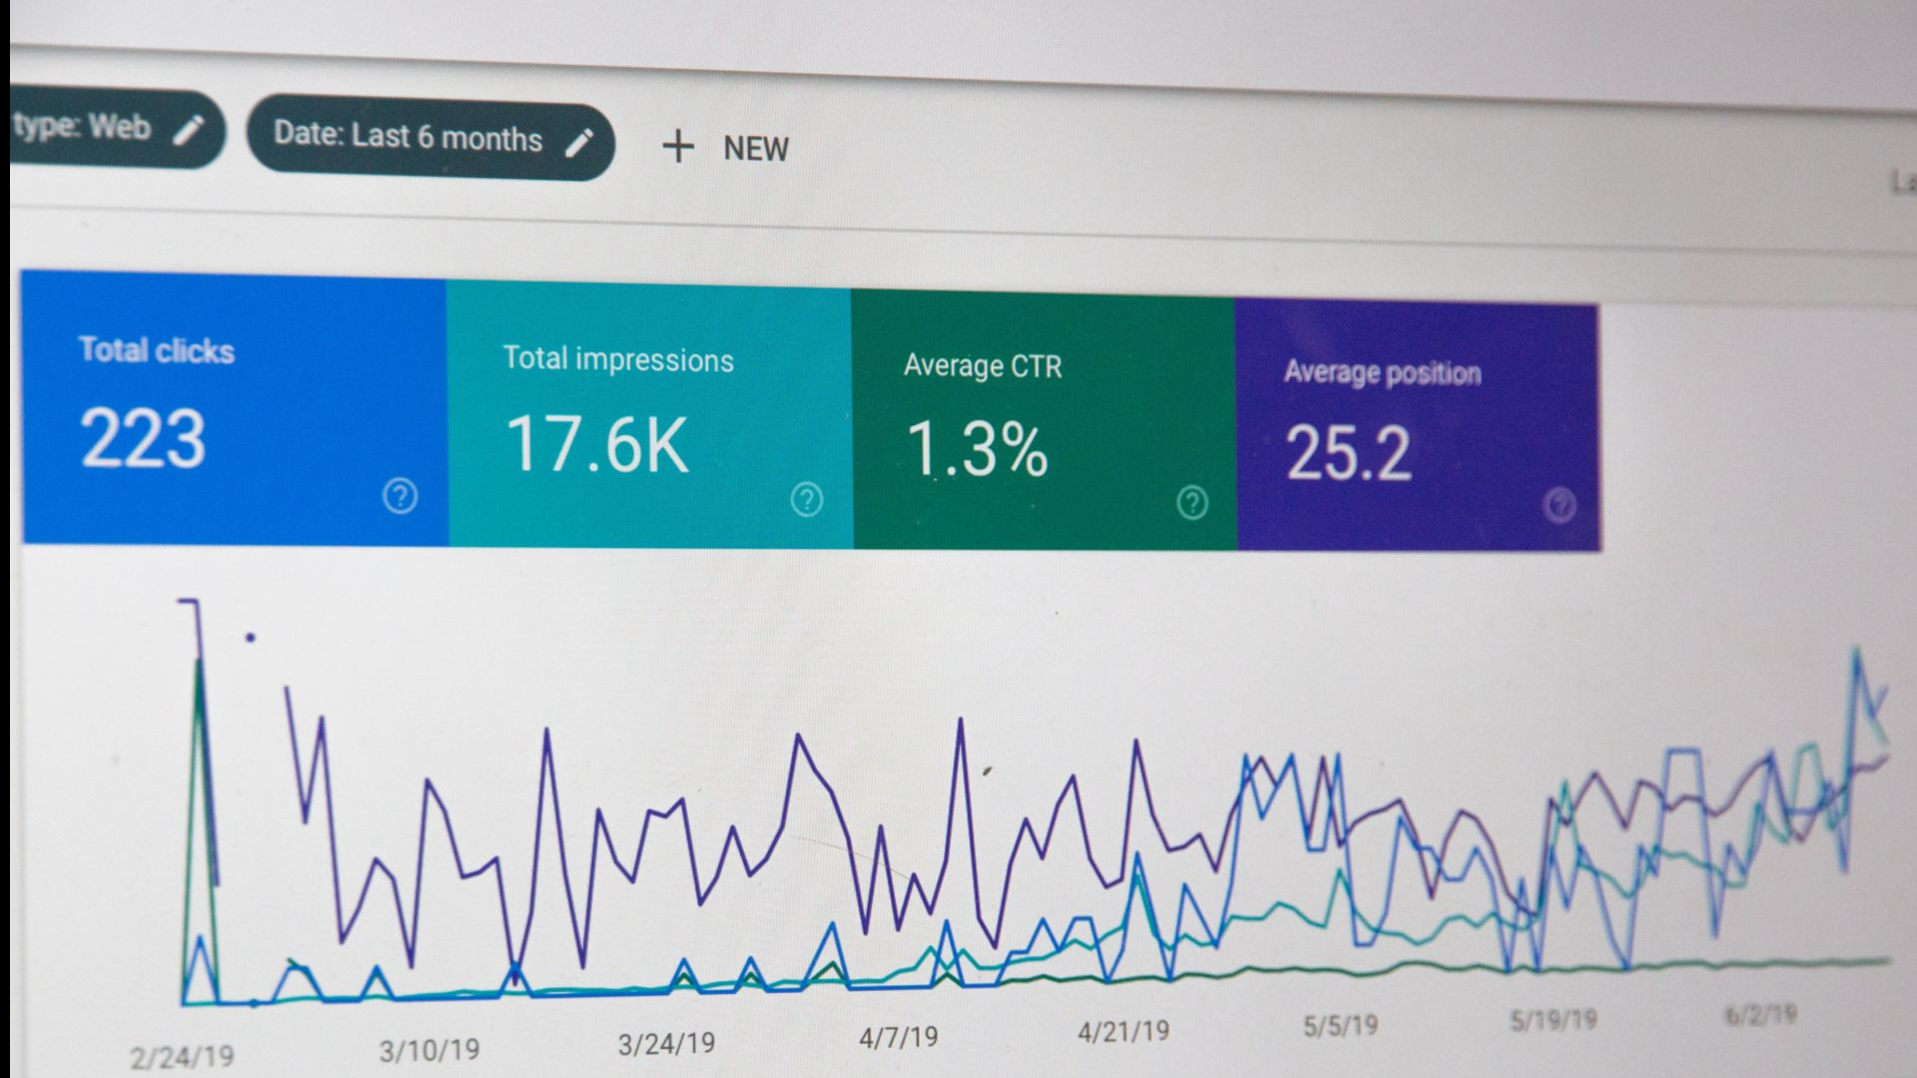

**Analyze objectives:** First, it enables you to understand the behavior

Of your target audience. By analyzing metrices such as traffic sources, bounce rate, time on site, and exit rate, you can gain insight into how users interact with your website and identify areas for improvement.

This information is vital and to implement effective tactics that optimize website traffic and improve conversion rates.

**Data collection:** website traffic analysis involves collecting and analyzing data about your website visitors so you can optimize the growth and conversations on your website.

Most common data collection methods.

* Manual counting
* Pneumatic tubes
* Inductive loops
* Video detection
* GPS tracking
* Transportation planning
* Traffic signal optimization
* Road capacity analysis

**Visualization:**  Data visualization can help you identify website traffic patterns by revealing trends,pattrens,outliers, and correlation.Such as line charts ,bar charts,pie charts,heat map or scatter plot.

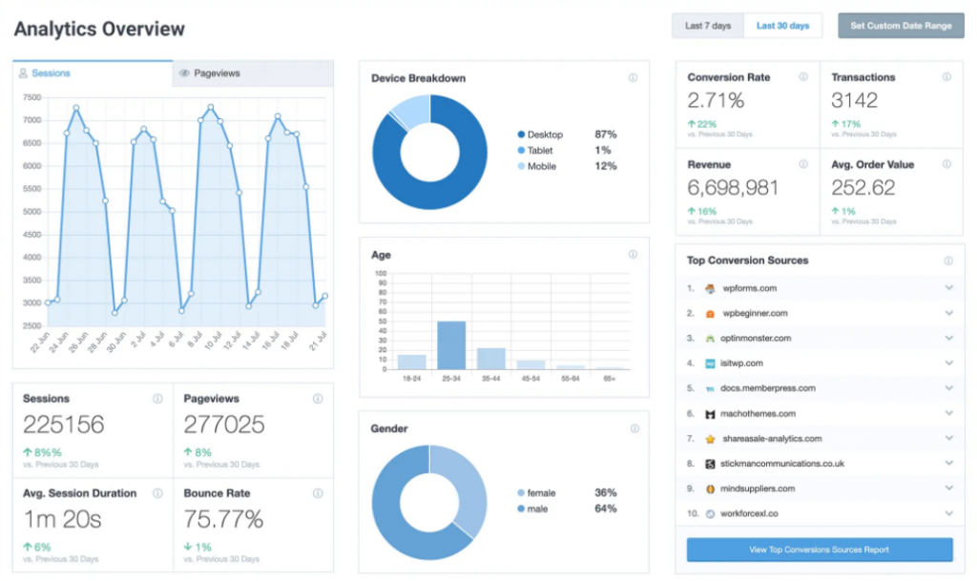

**Tools:**

* Mykinsta

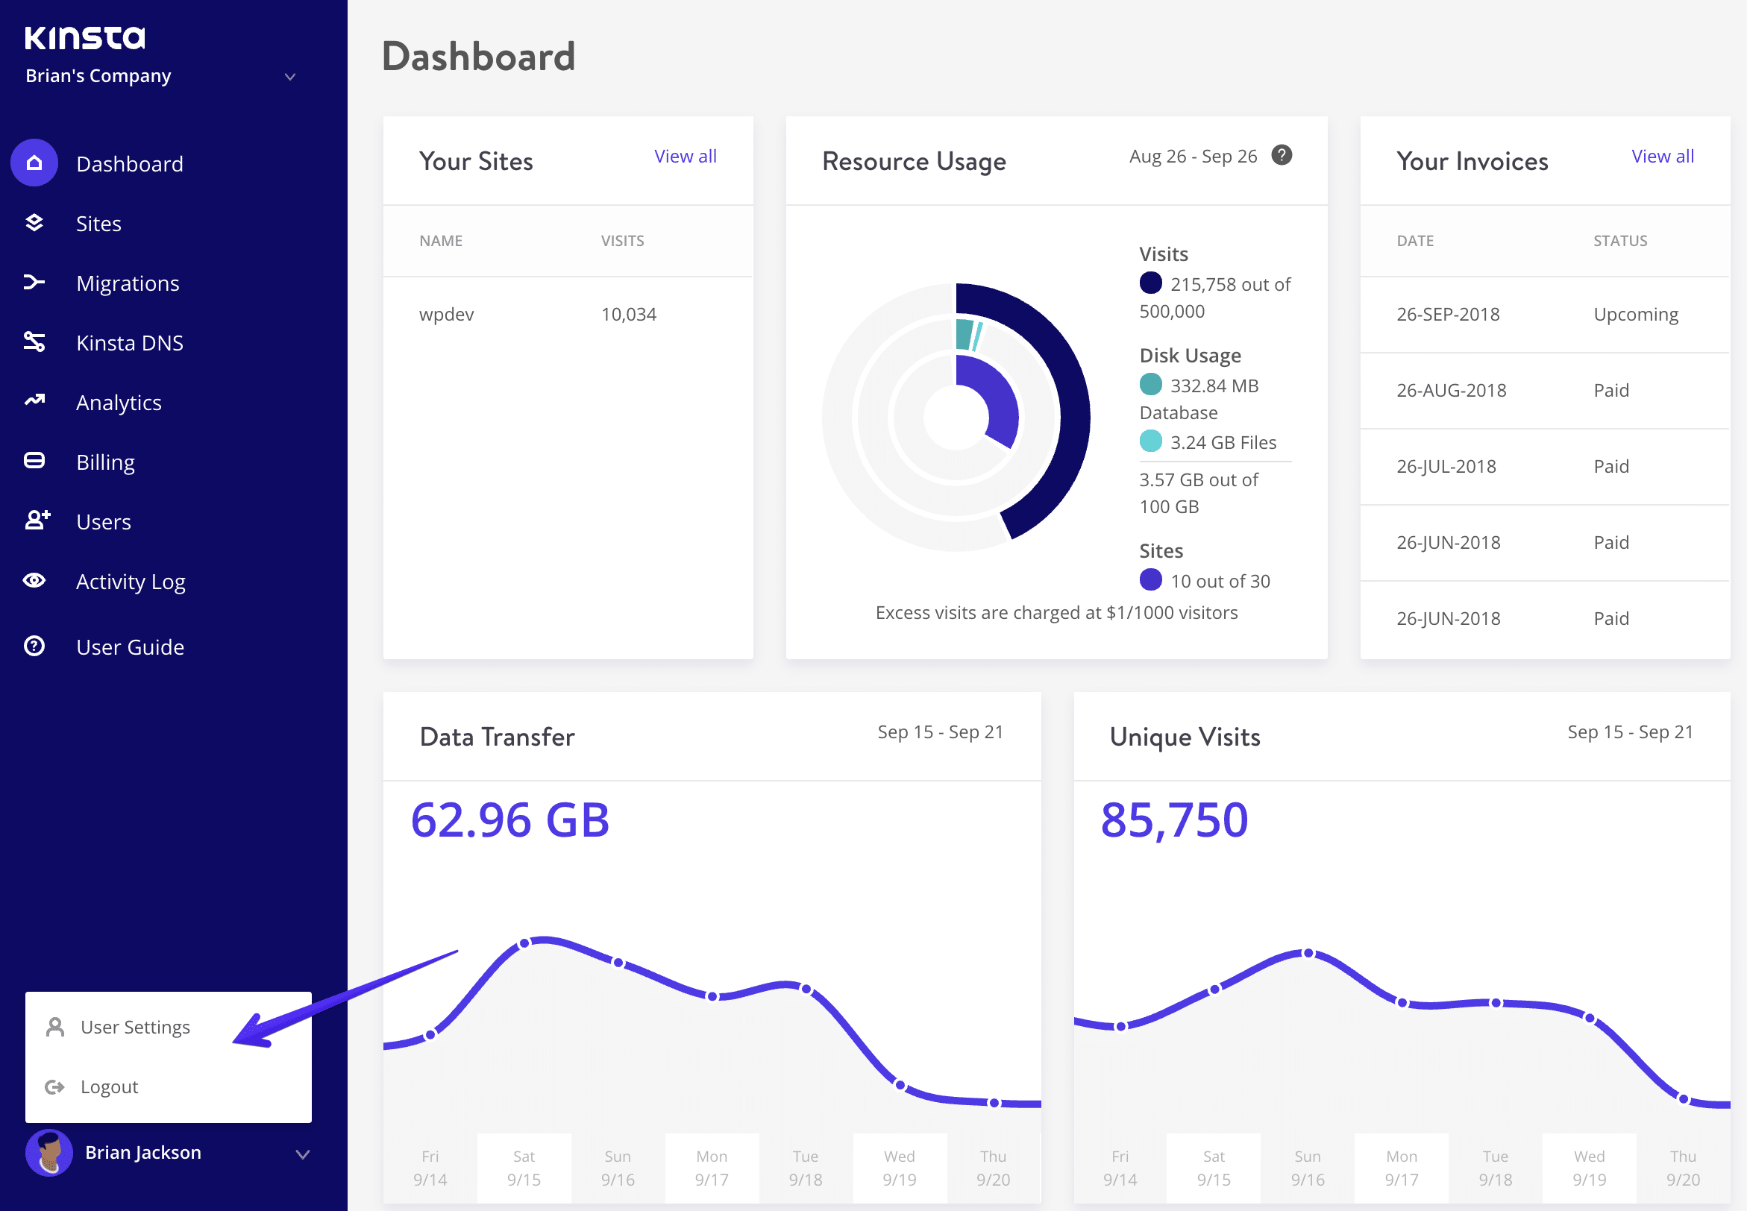

* Semrush
* Similarweb
* Sitechecker
* Serpstat
* Google analytics

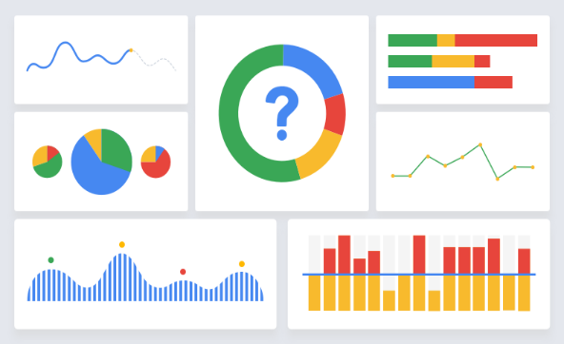

* Ubersuggest